USER MANUAL

Git Flow for PDF

**1.Working with GitHub**

* Sign up or sign in to GitHub account(https://github.com/)
* Create new repository

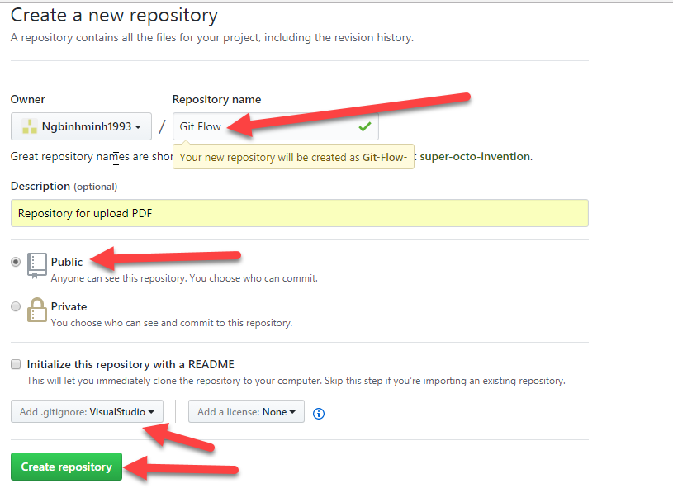

* The repository

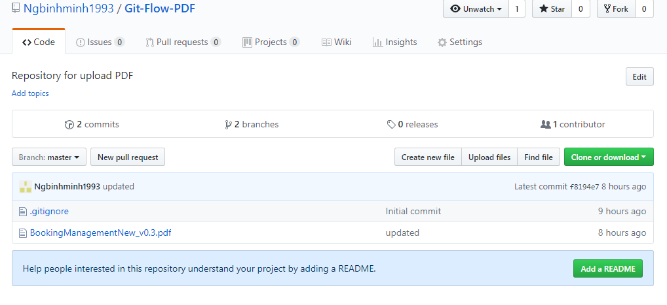

* Clone with HTTPS (use Git or check out using the Web URL)

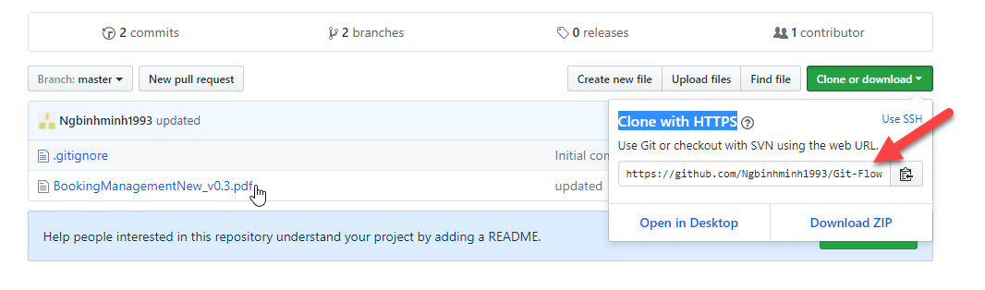

* Clone in Source Tree

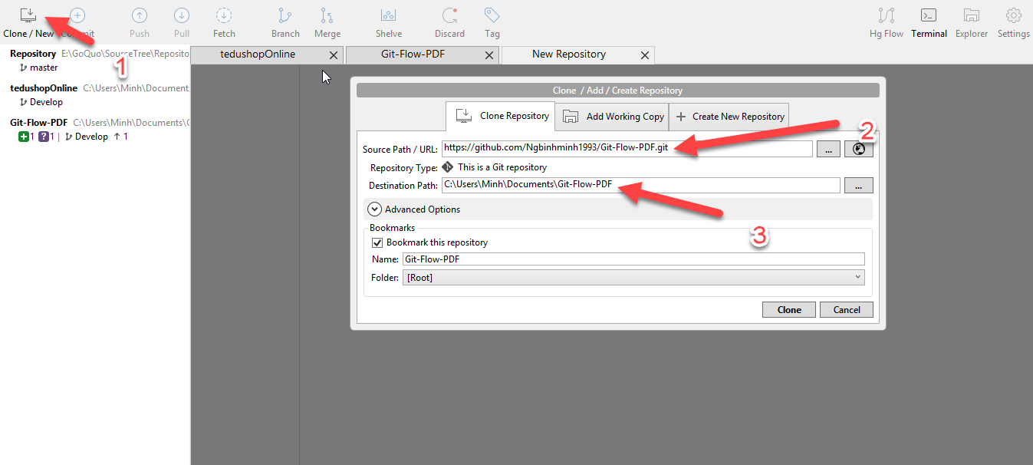

**2.Install and lauch Source Tree**

• Go to the [SourceTree website](https://www.sourcetreeapp.com/) (https://www.sourcetreeapp.com/) and click the download button.

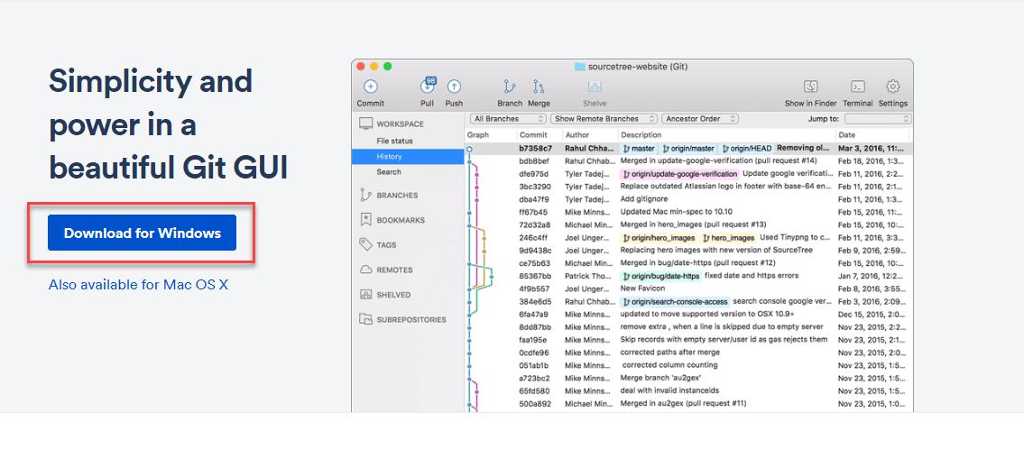

• Click the downloaded file (EXE for Windows) to open.

• We need an Atlassian account to use SourceTree. Click either **Use an existing account** or **Go to My Atlassian**and follow the prompts to [create a new account](https://id.atlassian.com/signup?application=mac&continue=https%3A%2F%2Fmy.atlassian.com%2Fproducts%2Findex).   
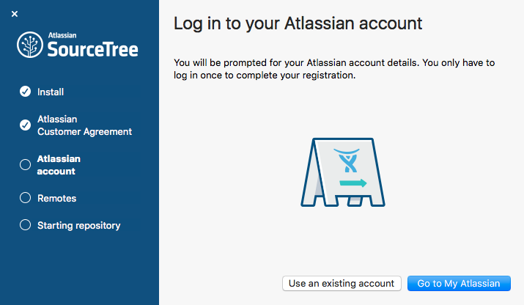

• If We want to connect to a remote server, We'll need to enter our Bitbucket or GitHub credentials. To enter your account's username and password, select **Basic** from the **Authentication**dropdown.  
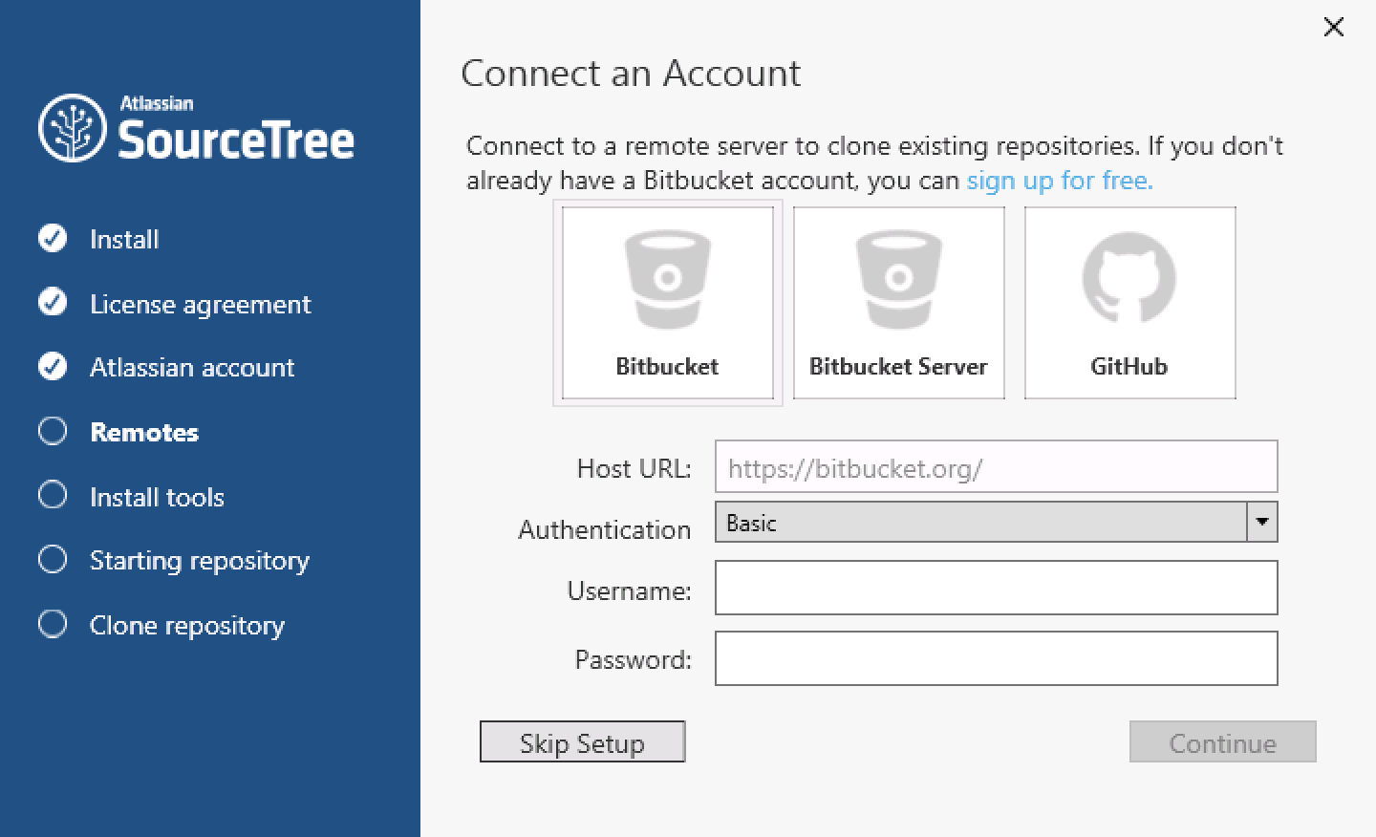

• Follow the prompts until we're done with the setup. If we aren't ready to clone a repository, click **Skip Setup**.

• Lauch Source Tree.

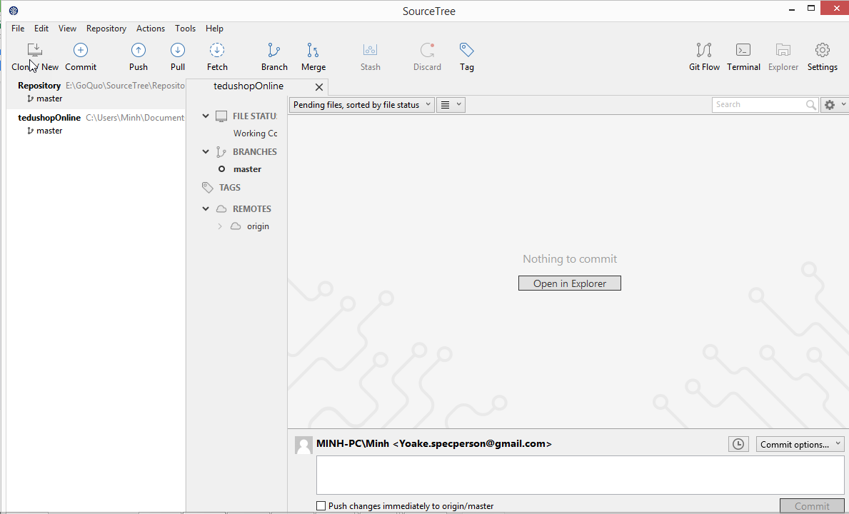

# • Commit and push a change (Git)

When we add a new file to your repository or make a change, we need to stage, commit, and push that change to your remote repository. After you make the change, we'll notice your new file in SourceTree.

# From the options menu of the new file, select ****Stage selected****

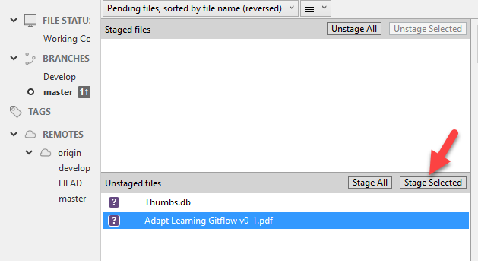

1. Click the **Commit** button at the top to commit the file.
2. In the message box, enter a commit message

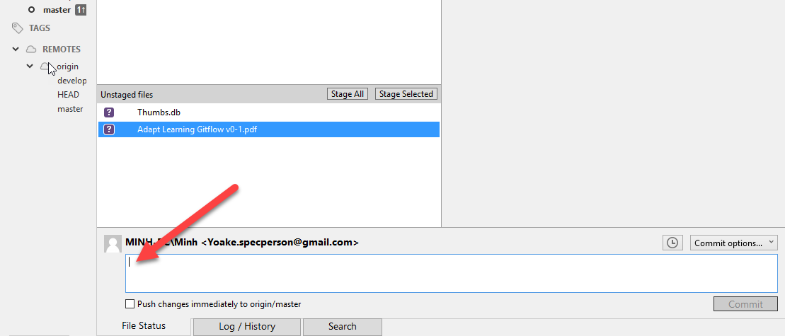

1. Click the **Commit** button under the box

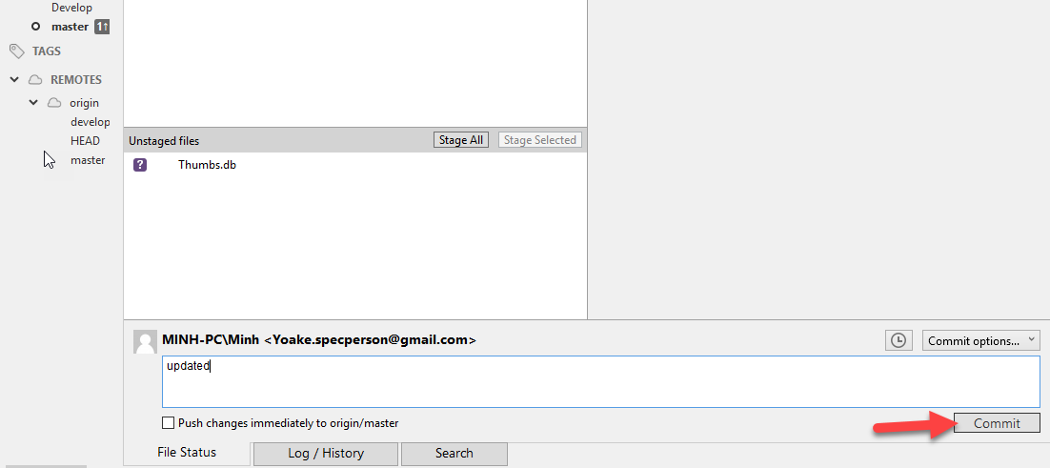

1. From SourceTree, click the **Push** button to push our committed changes

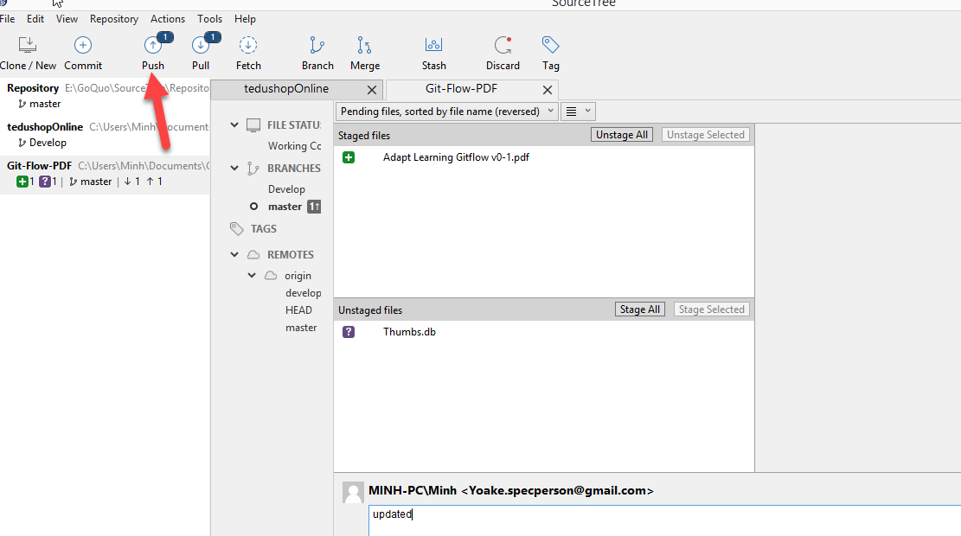

1. Under the **Push?** column from the dialog box that appears, select the master branch to indicate that you are pushing that branch to origin and click **Push**.

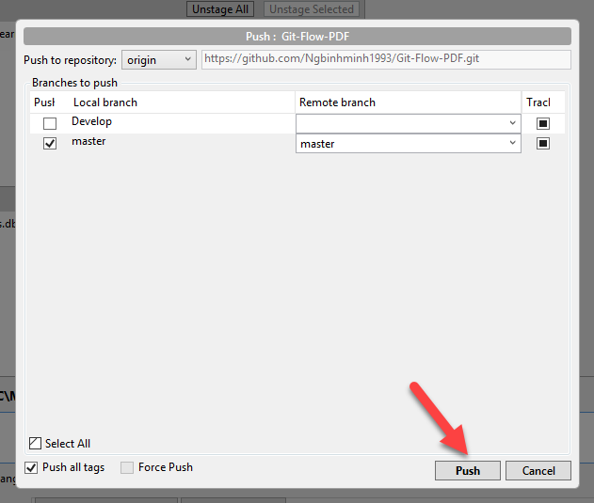

# • [Create and push a branch to the remote repository (Git)](https://confluence.atlassian.com/get-started-with-sourcetree/create-and-push-a-branch-to-the-remote-repository-git-847359118.html)

1. From SourceTree, click the **Branch** button.

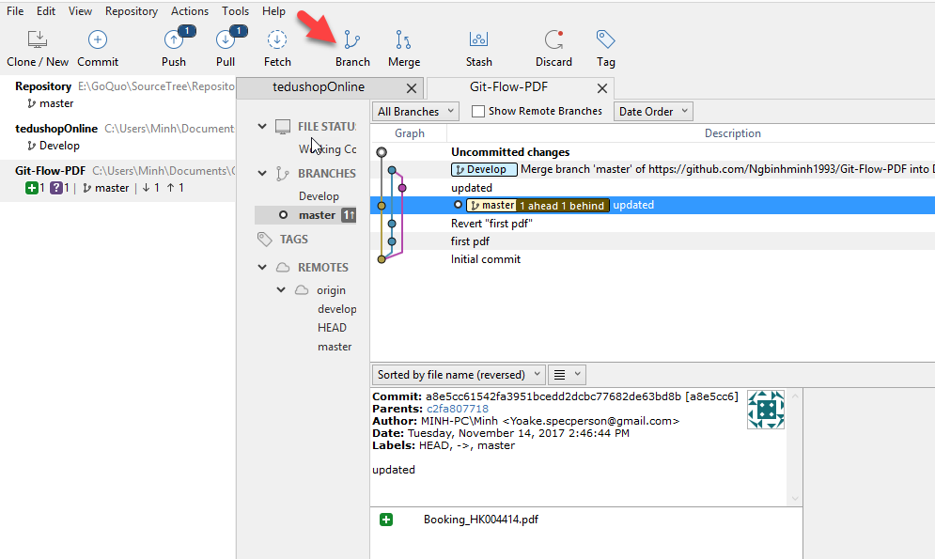

1. From the **New Branch**field, enter a name for your branch

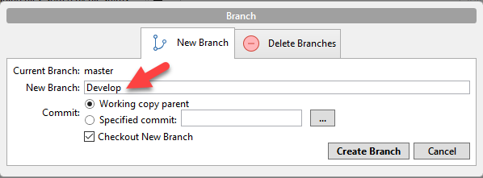

1. Click **Create Branch**.
2. We're now on our new branch. Make any updates to the repository that you want to make to your branch.

**3.Gitflow Workflow**

The GitFlow Workflow defines a strict branching model designed around the project release. This provides a robust framework for managing larger projects.

* **Develop and Master Branches**

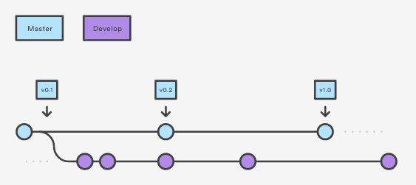

Instead of a single master branch, this workflow uses two branches to record the history of the project. The master branch stores the official release history, and the develop branch serves as an integration branch for features. It's also convenient to tag all commits in the master branch with a version number.

The first step is to complement the default master with a developbranch. A simple way to do this is for one developer to create an empty develop branch locally and push it to the server

**4.Git Flow for PDF**

* **Problem**

Tasks related to multiple and overlapping PDF updates. The same is a PDF but many people can update.

* **Process**

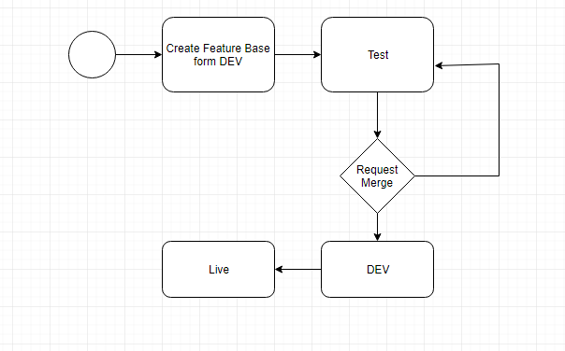

* **Git Flow**

